SPRINT 2 REPORT

## SMARTFARMER – IoT ENABLED SMART FARMING APPLICATION

**TEAM ID – PNT2022TMID15129**

* **TEAM LEADER : MANOJKUMAR M**
* **TEAM MEMBER : RAVIVARMA M**
* **TEAM MEMBER : SWETHAA SHREE V**
* **TEAM MEMBER : VARSHENI K C**

**Project Tracker**

|  |  |  |  |  |  |  |
| --- | --- | --- | --- | --- | --- | --- |
| **Sprint** | **Total Story Points** | **Duration** | **Sprint Start Date** | **Sprint End Date (Planned)** | **Story Points Completed (as on Planned End Date)** | **Sprint Release Date (Actual)** |
| Sprint-1 | 15 | 5 Days | 26 Oct 2022 | 30 Oct 2022 | 15 | 30 Oct 2022 |
| Sprint-2 | 15 | 7 Days | 31 Oct 2022 | 06 Nov 2022 | 15 | 07 Nov 2022 |
| Sprint-3 | 15 | 6 Days | 07 Nov 2022 | 12 Nov 2022 |  | 13 Nov 2022 |
| Sprint-4 | 15 | 6 Days | 13 Nov 2022 | 18 Nov 2022 |  | 18 Nov 2022 – 19  Nov 2022 |

# WORKDONE IN DASHBOARD :

As per user stories, we created a dashboard with data is represented in graphical representation with organized section in separate widget for better user understanding.

# DEVICES ESTIMATION :

* Temperature and Humidity Sensor
* Soil Moisture Sensor

Above sensor are used for sensing some parameters.

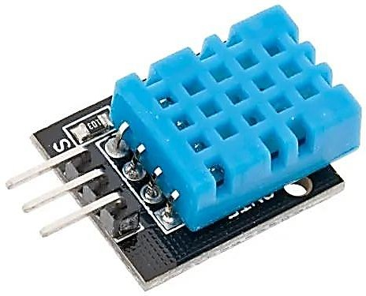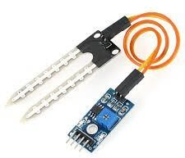

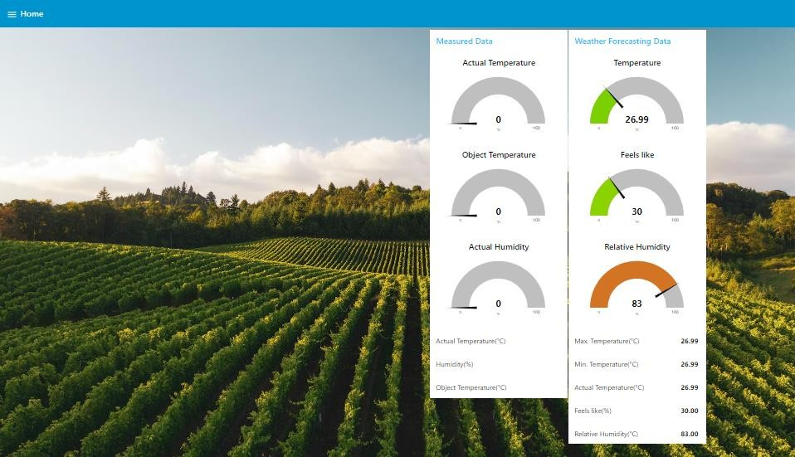

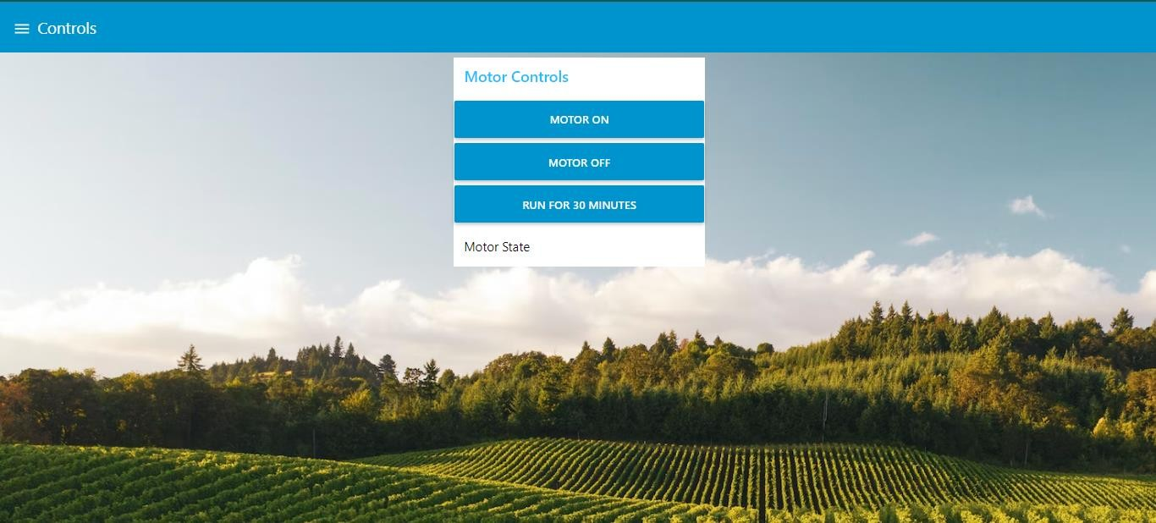

**Node Red Connection:**

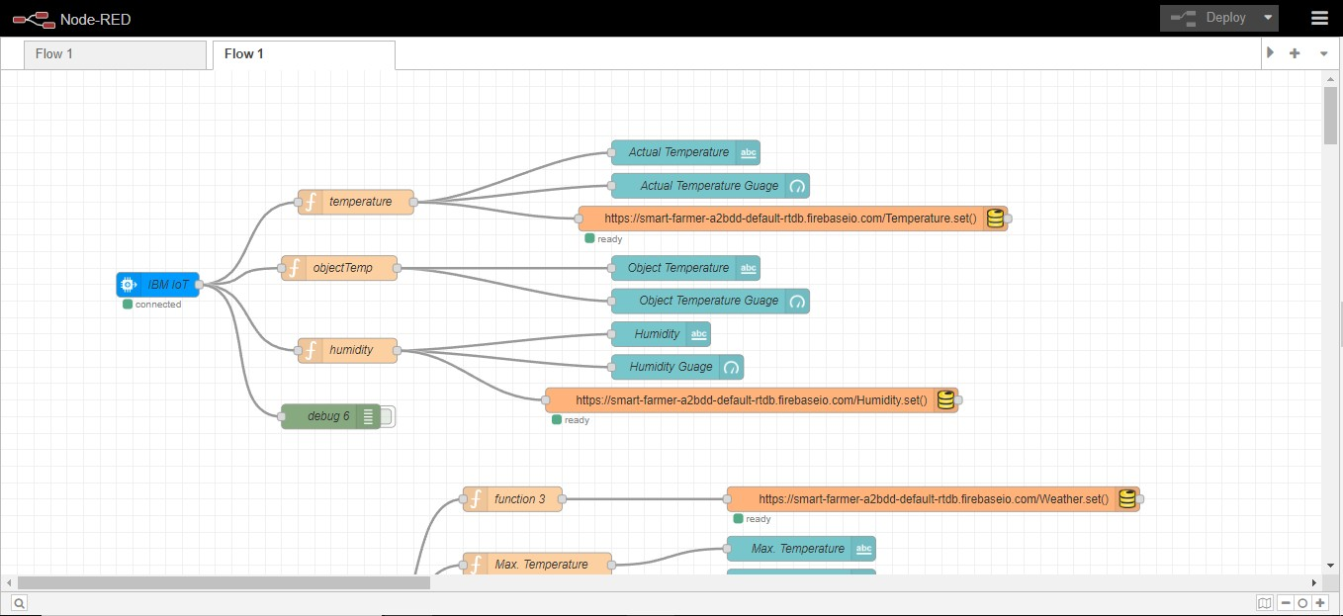

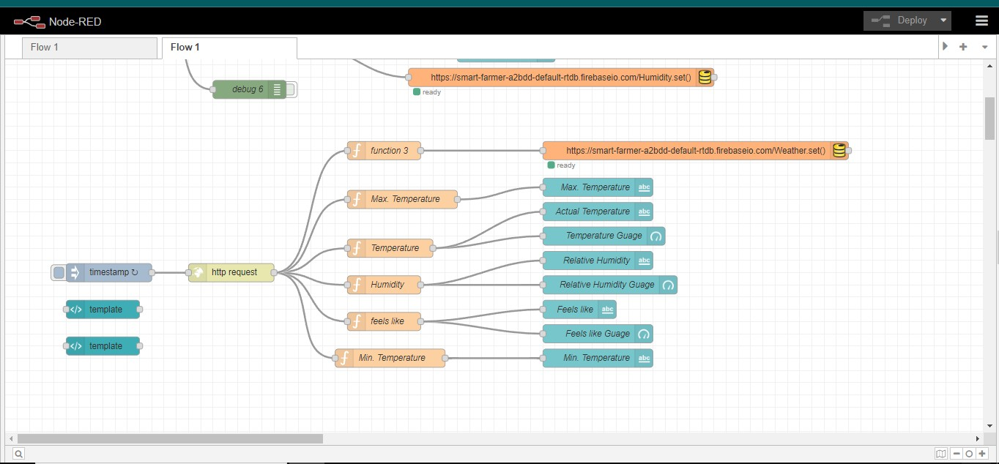

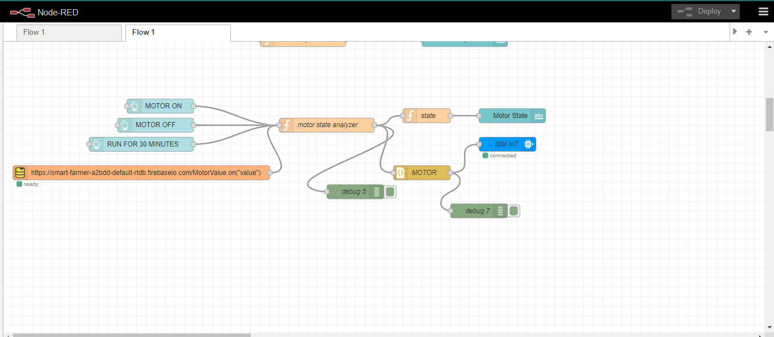

## Reports like Velocity Report, Burndown Report are attached below

     













